**Max485 Chip RS-485 Module TTL to RS-485 Module:**

[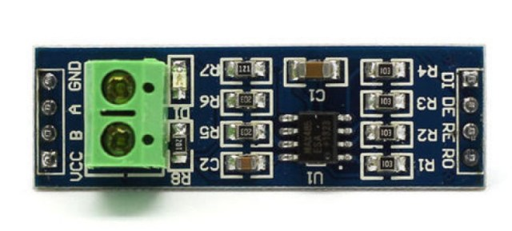](https://i0.wp.com/www.electroniclinic.com/wp-content/uploads/2021/03/rs345-or-max345-interface-module.jpg?ssl=1)

This is the MAX485 TTL to RS-485 interface module which is used to connect the Soil NPK Sensor with the Arduino as this interface module can be easily powered up using the Arduino’s 5 Volts. The max485 interface module is ideal for serial communications over long distances of up to 1200 meters or in electrically noisy environments, this is the reason it is commonly used in industrial environments. It supports up to 2.5MBit/Sec data rates, but as the distance increases, the maximum data rate that can be supported comes down. The RS-485 has the ability to communicate with multiple devices (up to 32) on the same Bus/cable when used in master and slave configuration. I have already written a detailed article on how to use the MAX485 interface module with Arduino and communicate with multiple controllers. So, I highly recommend reading this article.

**KEY FEATURES OF MAX485 TTL TO RS-485 INTERFACE MODULE:**

* Use MAX485 Interface chip
* Uses differential signaling for noise immunity
* Distances up to 1200 meters
* Speeds up to 2.5Mbit/Sec
* Multi-drop supports up to 32 devices on the same bus
* Red power LED
* 5V operation

**MAX485 Pinout:**

We have 4 male headers on the data side,

**RO** is the receiver output and it should be connected with the RX pin of the Arduino.

**RE** is the Receiver Enable. This is active low. This pin should be connected with the Arduino’s digital output pin. Drive LOW to enable receiver, HIGH to enable Driver.

**DE** is the Driver enable pin. This is Active High and is typically jumpered to the RE Pin.

**DI** is the Driver Input and it should be connected with the TX pin of the Arduino.

Similarly,

We have 4 male headers on the Output side,

**VCC** pin should be connected with the Arduino’s 5 volts.

**B** and **A** pins should be connected with the B and A pins on the far end module; in our case, we will connect these with the B and A wires of the Soil NPK Sensor.

**GND** pin should be connected with the Arduino’s ground.

1X2 Screw Terminal Block (Output Side)

* **B** = Data ‘B’ Inverted Line. Connects to B on far end module
* **A** = Data ‘A’ Non-Inverted Line.  Connects to A on far end module